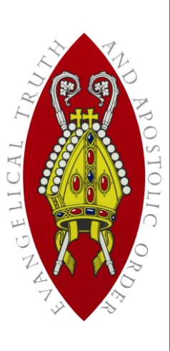
The Scottish Episcopal Church

United Diocese of Glasgow & Galloway

Guidelines for a Grant Application from the Growth Fund

The Growth Fund is a diocesan fund administered by the Development Convenors. Each year it supports a number of projects and initiatives with small grants up to £2000. Projects may well cost more than this and applicants may apply for larger amounts, but granting a sum larger than £2000 will be at the Bishops discretion. The grants are intended to enable local Charges achieve their missional aims. The grants should therefore promote spiritual and numerical growth assisting Charges in missional outreach to their community. It is important to understand that the grants are for mission, i.e., taking the Good News of Jesus in word and deed to those we live and work amongst.

The Development Convenors meet 6 times annually and review the applications. They look particularly for creative, exciting and innovative projects.

May we invite you to read below the main criteria for the award of a grant and if your project fits these we would welcome an application. The process may take up to 3 months, but hopefully less. It may be that the award is given pending further information and generally an update/report will be required on the projects delivery.

Criteria

- A grant may only be awarded to a Scottish Episcopal Church in the Diocese of Glasgow & Galloway.
- A grant may be up to but rarely in excess of £2000
- A grant may be awarded for missional purpose only in the spirit of the MAP process within the diocese. For the purposes of this Fund, Mission is defined as: any activity that demonstrates the love and compassion of Christ and will include His invitation to a new life, human flourishing and a deepening relationship with God.
- The need for the project for which a grant is sought should be made clear
- The number and groups of people who will benefit from the projects should be identified.
- We would also be interested in how you would communicate with the beneficiaries – or simply, those you wish to be a part of the project.
- It is expected that a grant will normally, but not always, be a percentage of rather than the full amount needed for the project. In other words, we encourage other funders to be stake-holders in your project, and of course the congregation raising some funds too.
- Normally we would expect the charge seeking a grant to have a Mission Action Plan or other mission strategy document.
- We would really wish to see that any grant awarded is actually making the difference we and the charge anticipated. So, we ask you to help us by identifying how you will know that the project is working and doing what you wanted it to do.
- An Update/Report will be required after 1 year: this will give the Committee information to report to the Diocese that grants are achieving what they set out to achieve with accountable stewardship.

Three Examples of Projects awarded a Grant from the Regional Development Fund.

- St Mary the Virgin, Port Glasgow.
Application for: A Projector & Projector Trolley

St Mary’s is in the heart of the former Lower Clyde Shipbuilding area. The church, aware of the substantial number of former shipyard workers, not only in the congregation but in the wider community, felt they should hold a monthly Lunch Club. Not only would this be a rendezvous for men with a shared past, but an opportunity for shared learning through invited speakers giving an illustrated talk on ship-building, engineering and related topics. The modern church had refitted a room in the church complex with local grants, donations from the congregation and with labour from the local community justice programme. Whilst a laptop as available for PowerPoint slides a high resolution/ lumen projector was needed.
The Regional Development fund awarded a grant for the projector and projector trolley.

- All Saints, Jordanhill.
Application for: Evangelism Course Equipment & Materials

As part of their MAP for the first year All Saints wished to run the 8-week Discipleship Explored course. Enthusiasm was such in the congregation that the neighbouring Jordanhill Parish Church asked to be included. The request to the Fund was for equipment and print materials to run the course: (1) 1000 distribution leaflets to advertise the course and All Saints’ up-coming Christmas Services to the local community; (2) purchase of the DVD, handbooks and New Testaments (3) a Smart LED -tv, (4) supporting equipment.
The Regional Development Fund awarded a grant for all 4 components of this evangelism and missional project.
- St Ninians, Troon.
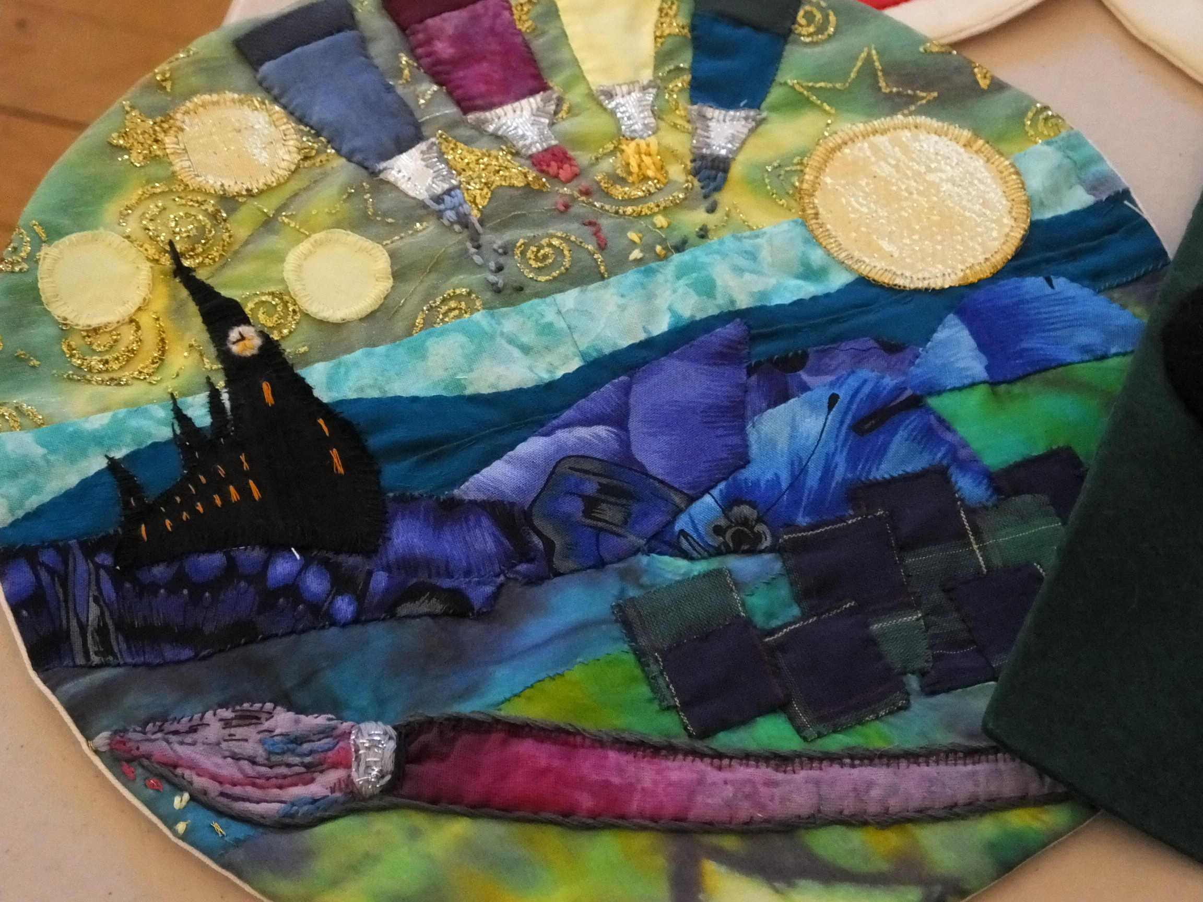
Application for: Community Art Project
Inspired by the Great Tapestry of Scotland, St Ninian’s congregation wanted to outreach to the wider community of the town and decided on an Inter-Generational Art Project. Called the Great Troon Wall it has brought adults and every primary school in Troon together in this learning experience with the Episcopal Church at its centre.

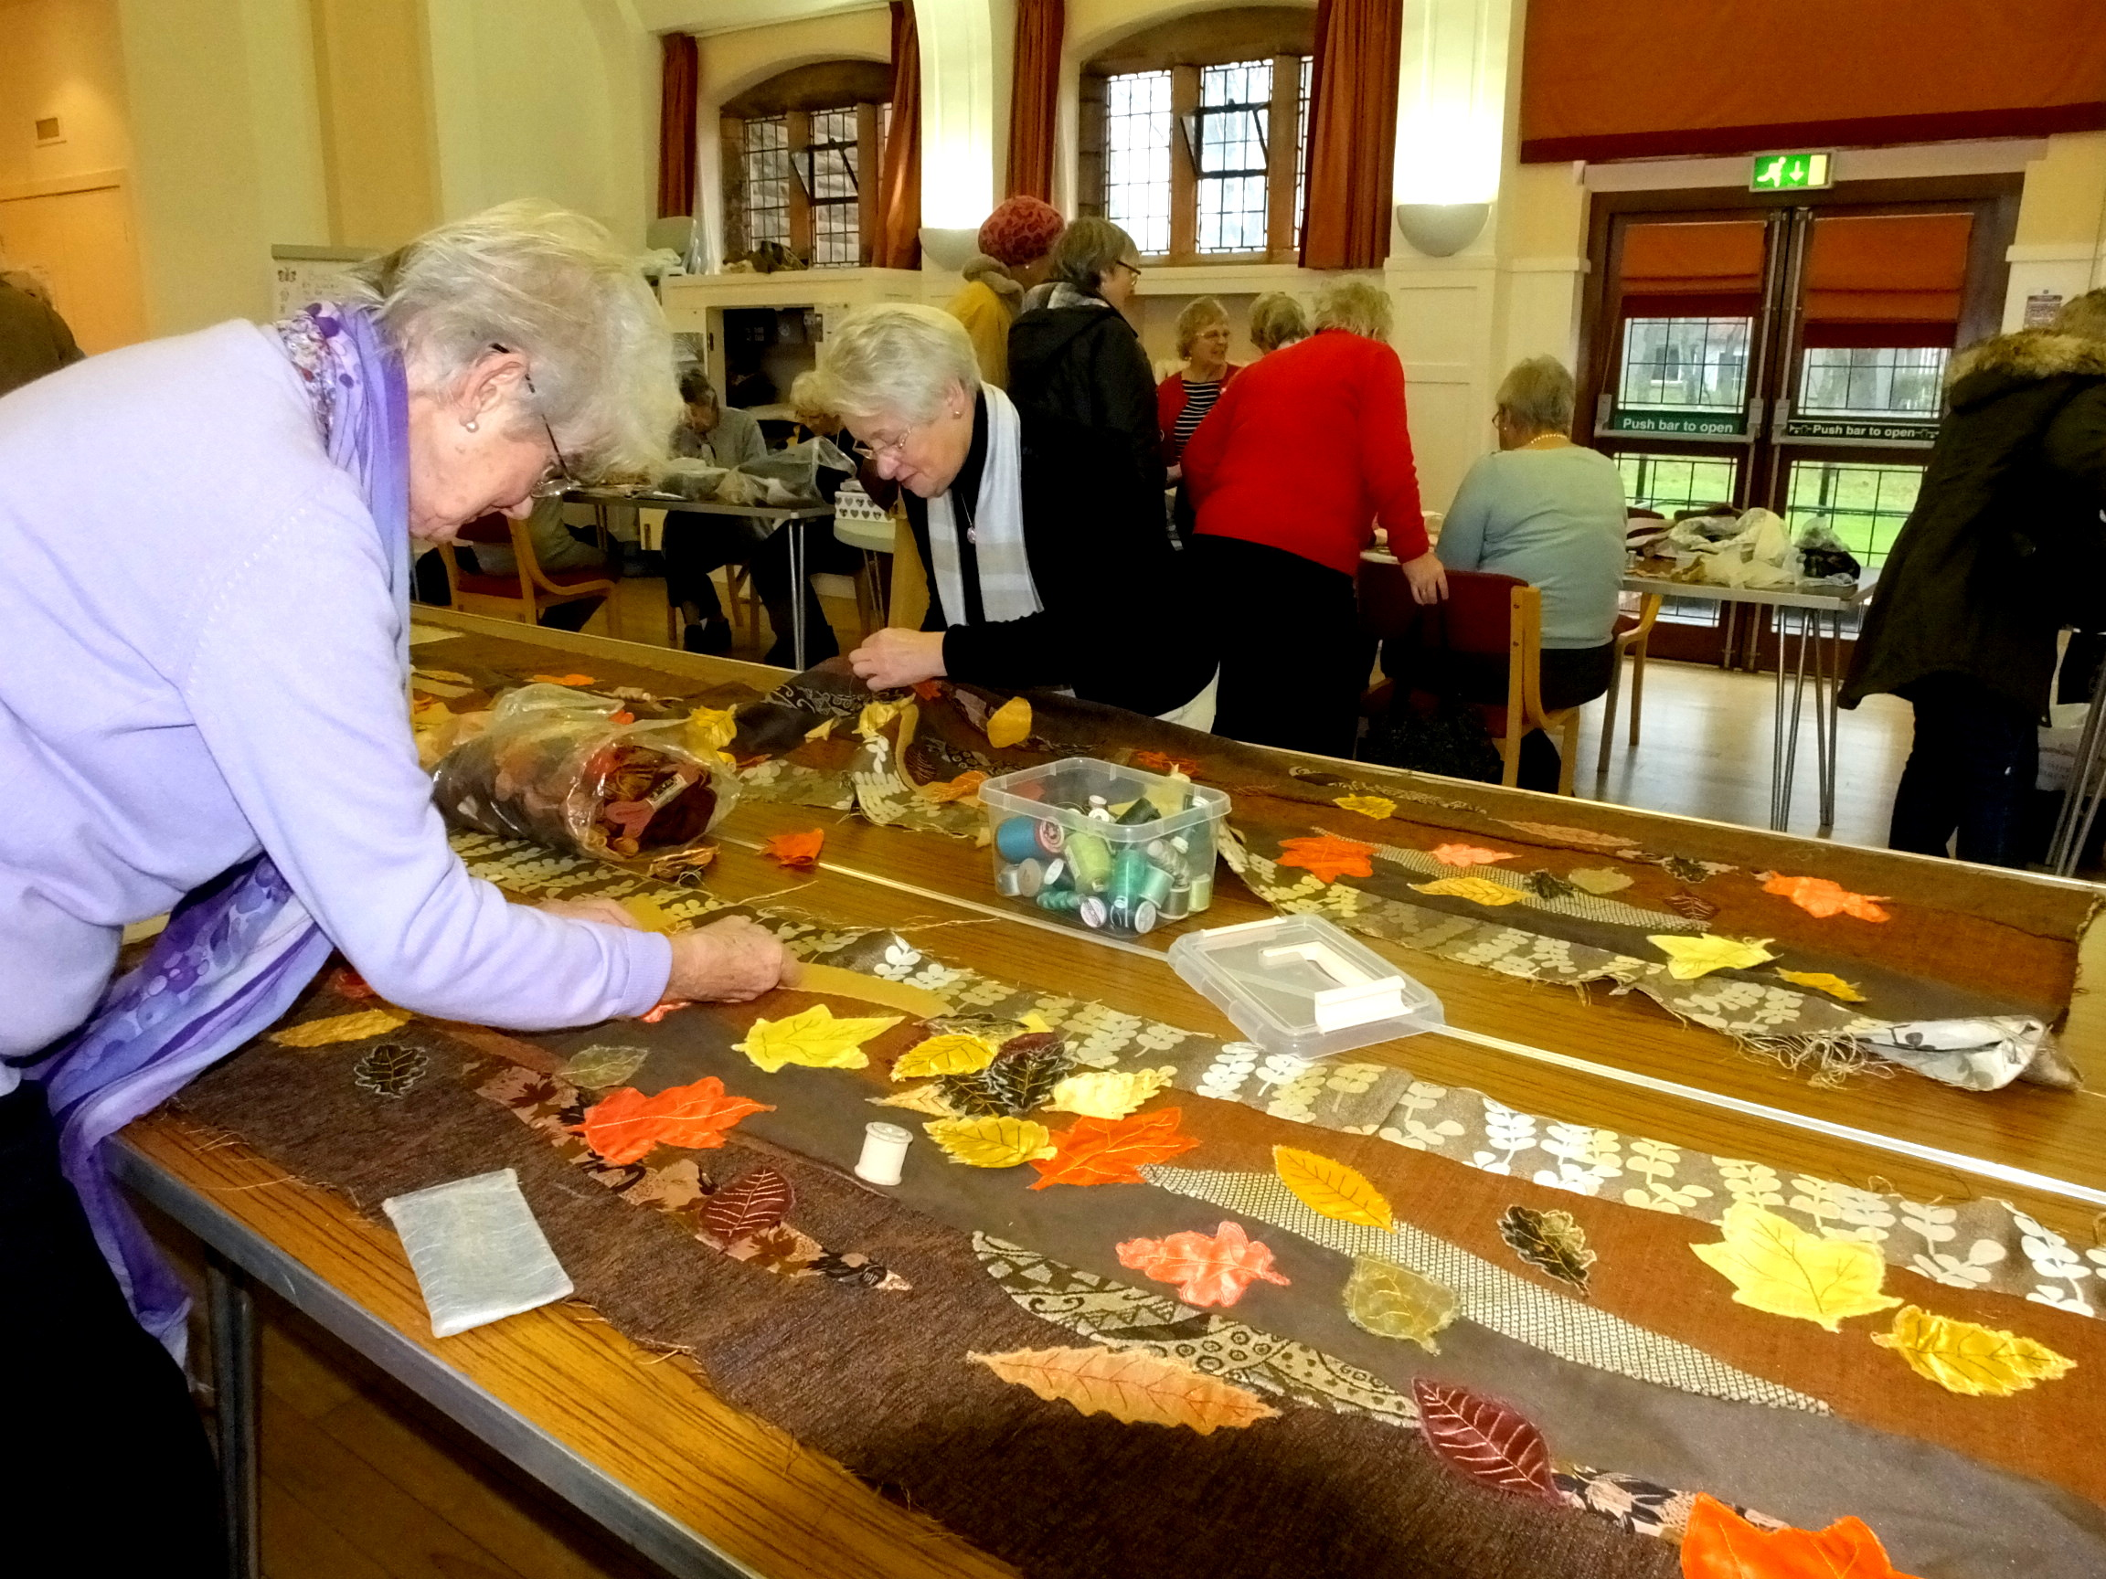
It has captured the local community’s imagination and has prompted the donation of much of the material needed. The effect has been to bring the life and witness of St Ninian’s to the consciousness of the town; new people have been invited to the church services and started attending St Ninian’s as a result.

The Regional Development fund awarded a grant for project development costs but especially for the design and construction of the huge frame that will hold the Great Troon Wall.

